Máxima, Prinsess of the Netherlands, Prinsess of Oranje-Nassau, Mrs. van Amsberg (born Zorreguieta Cerruti; Buenos Aires, Argentina, 17 May 1971), is the wife of crown prince Willem-Alexander van Oranje-Nassau, and soon to be queen of the Netherlands. She possesses both the Dutch and Argentine nationality. Together with her husband, she has three daughters: Amalia (2003), Alexia (2005) and Ariane (2007).
She studied economics at the Universidad Católica Argentina and worked in New York from 1995 till 2000 for various banks. In April 1999 she met Willem-Alexander during a party in Sevilla, Spain, and on 30 March 2001, Queen Beatrix announce their engagement.
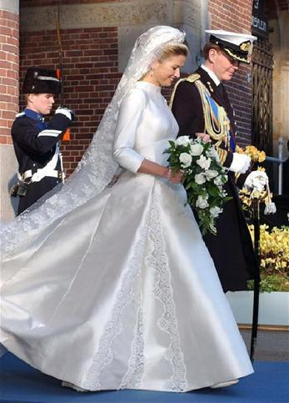
On 2 February 2002 the couple was married in Amsterdam, Maxima wore a dress designed by Valentino Garavani.
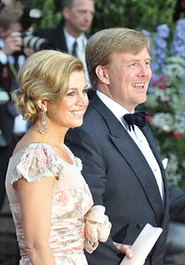
Maxima is member of a Comity regarding participation of women from ethnical minorities, which advises the government regarding integration. Furthermore she is patroness of the Oranje Fonds and the Dutch scouting, and has a lot of official obligations.

